**Name & ID**: Basil khowaja bk08432 **Date:** 12 nov 2024

|  |
| --- |
| **EE-424L Data Communication & Networking**  **Fall 2024**  **Habib University**  **Dhanani School of Science & Engineering** |

LAB 10: Open Shortest Path First (OSPF) Routing

|  |  |  |  |  |  |  |  |  |  |  |  |  |  |  |  |  |  |  |  |  |  |  |
| --- | --- | --- | --- | --- | --- | --- | --- | --- | --- | --- | --- | --- | --- | --- | --- | --- | --- | --- | --- | --- | --- | --- |
| **Lab #10 Marks distribution:**   |  |  |  |  |  |  | | --- | --- | --- | --- | --- | --- | |  |  | **LR2=30** | **LR4=30** | **LR5=30** | **AR4=10** | | **In-Lab Tasks** | **Task 1** | /10 | /10 | /10 | /10 | | **Task 2** | /20 | /20 | /20 | | **Marks Obt.** | **/100** | | | | | |

|  |  |
| --- | --- |
| o**bjectives** | **The objective of this lab is to configure and verify Single and Multi-Area Open Shortest Path First (OSPF) Routing.** |

**Introduction**

**OSPF (Open Shortest Path First)** is a link state routing protocol. Because it is an open standard, it is implemented by a variety of network vendors. OSPF will run on most routers that doesn’t necessarily have to be Cisco routers (unlike EIGRP which can be run only on Cisco routers).

Here are the most important features of OSPF:

* a classless routing protocol
* supports VLSM, CIDR, manual route summarization, equal cost load balancing
* incremental updates are supported
* uses only one parameter as the metric – the interface cost.
* the administrative distance of OSPF routes is, by default, 110.
* uses multicast addresses 224.0.0.5 and 224.0.0.6 for routing updates.

Routers running OSPF have to establish neighbor relationships before exchanging routes. Because OSPF is a link state routing protocol, neighbors don’t exchange routing tables. Instead, they exchange information about network topology. Each OSFP router then runs SFP algorithm to calculate the best routes and adds those to the routing table. Because each router knows the entire topology of a network, the chance for a routing loop to occur is minimal.

Each OSPF router stores routing and topology information in three tables:

* **Neighbor table** – stores information about OSPF neighbors
* **Topology table** – stores the topology structure of a network
* **Routing table** –  stores the best routes

|  |  |  |
| --- | --- | --- |
| **Task 1: Configuration of Single Area OSPF** |  | |
|  | |  |

Configure and create the below topology in packet tracer and complete the IP configuration and interface configuration in Table 1 according to your Network Topology. Attach your network topology with labelled IPs and interfaces below.

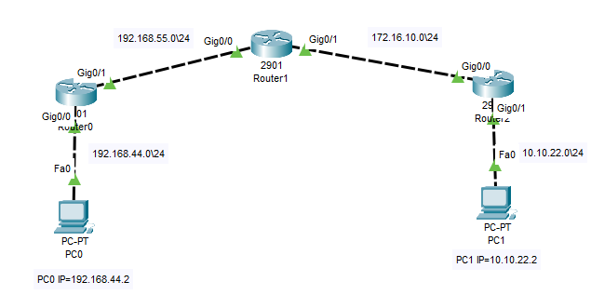

**Note: Make sure to enter correct subnet masks as mentioned in above topology**

|  |  |  |
| --- | --- | --- |
| **Device Name** | **Protocol Configuration** | **IP Scheme/Interface Configuration** |
| PC0 | -- | 192.168.44.2 |
| PC1 | -- | 10.10.22.2 |
| Router0 | ospf | 192.168.44.1  192.168.55.1 |
| Router1 | ospf | 192.168.55.2  172.16.10.1 |
| Router2 | ospf | 172.16.10.2  10.10.22.1 |

**Ping PC0 to PC1 and note the response below.**

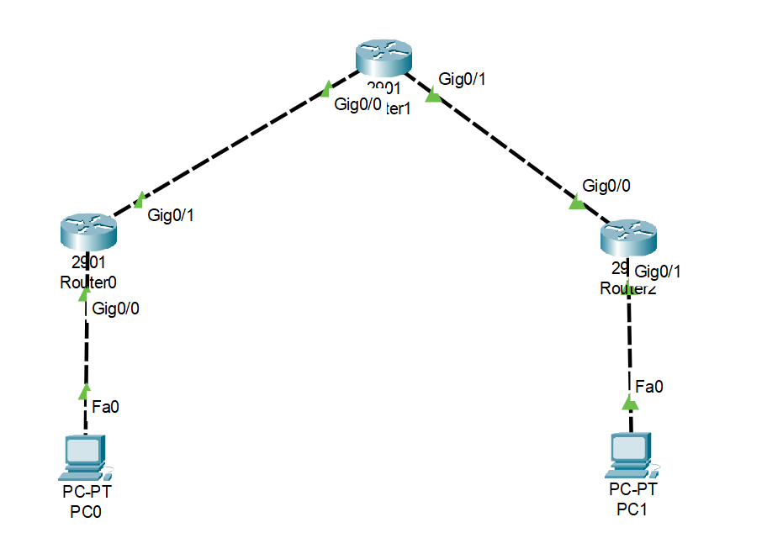

|  |
| --- |
|  |

**Configure and verify Open Shortest Path First (OSPF) Routing**

Configure an OSPF routing process on all routers. Use OSPF process number 1 and ensure all networks  
are in area 0. The first command enables an OSPF process under the specified process ID. We can run multiple OSPF processes on a router. OSPF uses the process-id to identify each process. The process_ID is a numeric value. It can be any number from 1 to 65,535. It is locally significant.

For configuring any router with OSPF you need to advertise all the directly connectednetwork in OSPF process**.** For example, on router0 you have the networks 192.168.44.0/24 and  
192.168.55.0/24

**Router 0 OSPF Configuration:**

Router0#conf t  
Router0(config)#router ospf 1  
Router0(config-router)#network 192.168.44.0 0.0.0.255 area 0  
Router0(config-router)#network 192.168.55.0 0.0.0.255 area 0

Router0(config-router)#router-id 1.1.1.1

We have used the**router-id 1.1.1.1** command to manually specify the router ID of this router. OSPF process will use that RID (router-id) when communicating with other OSPF neighbors. Do it for Router 1 & 2 with router-ids 2.2.2.2 and 3.3.3.3 respectively and attach its screenshot below:

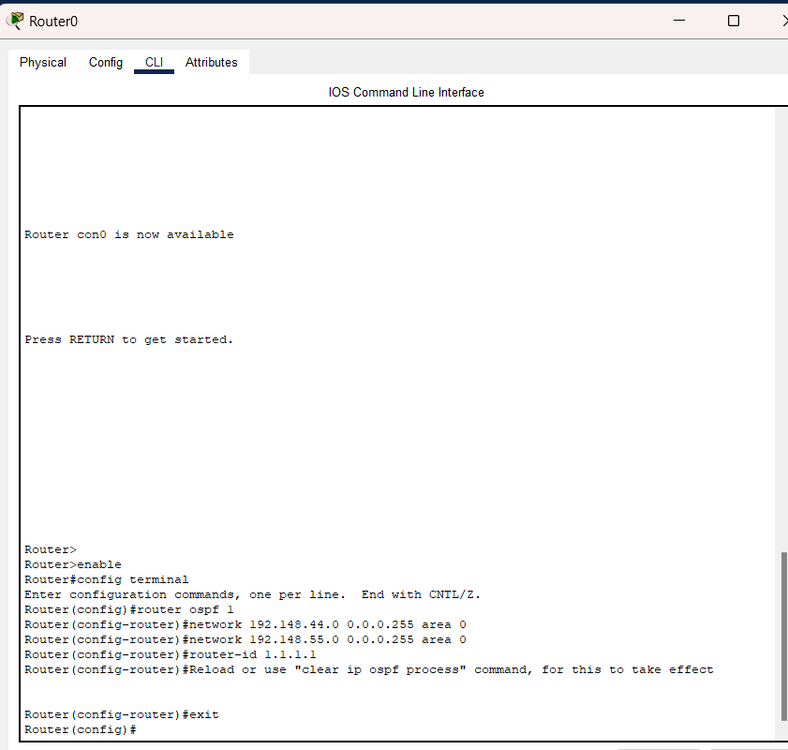

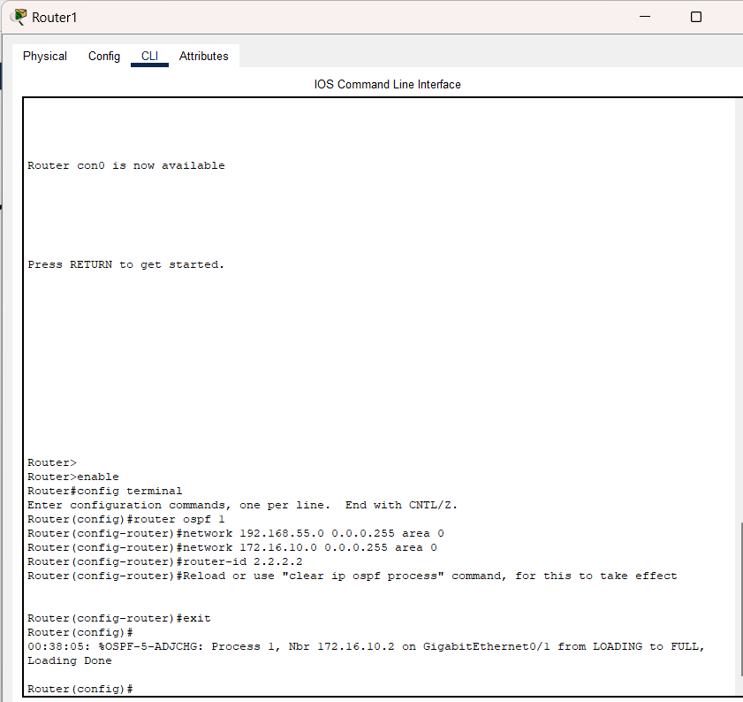

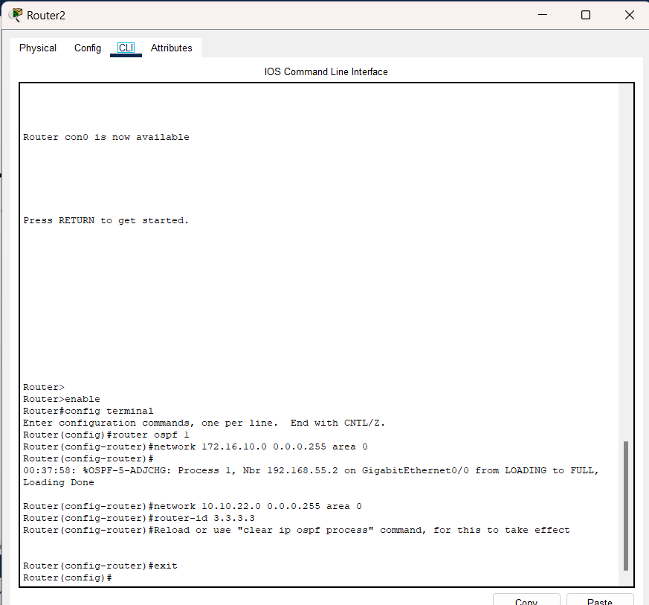

Ping PC0 to PC1 and write down the response.

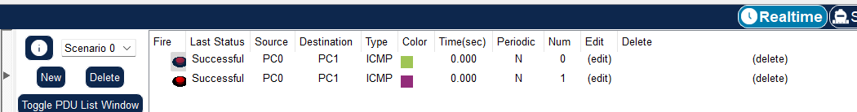

**OSPF verification commands:**

Run **show ip protocol** on any one Router and **show ip route** on all routers and discuss the results.

Router 0:

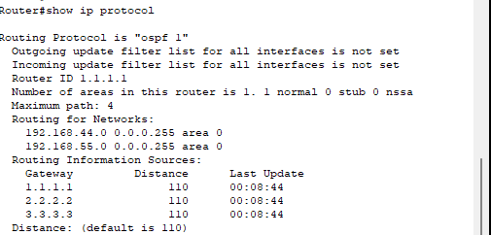

The output confirms that OSPF process 1 is active. The list of networks advertised includes 192.168.44.0/24 and 192.168.55.0/24, and the router ID is set to 1.1.1.1.

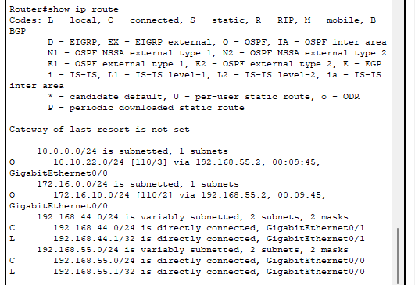

Router 1:

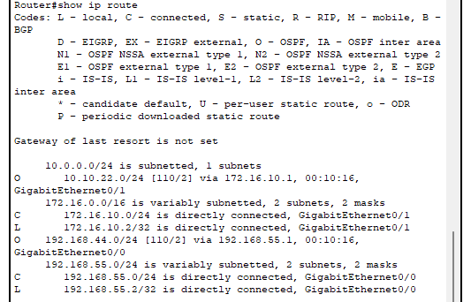

Router 2

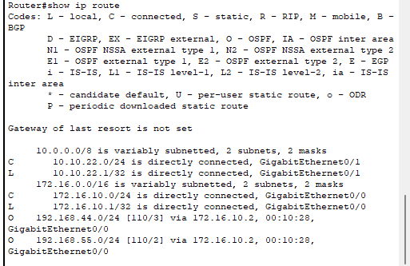

All routers show OSPF routes in the routing table with an distance of 110. Routes to connected networks have been learned correctly by the routers and the next hops are displayed

Run below commands, attach its screenshot and **discuss the results.**

* show ip ospf neighbor: Run this command on Router 0, 1 and 2
* 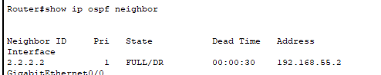
* Router0 lists Router1 as a neighbor with state FULL/DR (Designated Router). The dead timer is set to 30 seconds, indicating active OSPF communication. The neighbor's IP address and interface confirm proper OSPF adjacency.

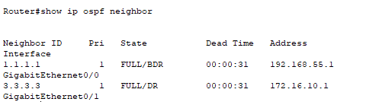

Router1 lists Router0 and Router2 as neighbors. Router0 is in state FULL/BDR (Backup Designated Router), while Router2 is FULL/DR. This confirms Router1's adjacency with both neighbors and correct OSPF election

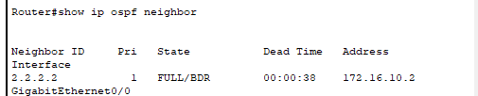

* show ip ospf interface: Run this command on any one Router

Router2 lists Router1 as its neighbor with state FULL/BDR. The dead timer is functioning correctly, confirming active OSPF sessions.

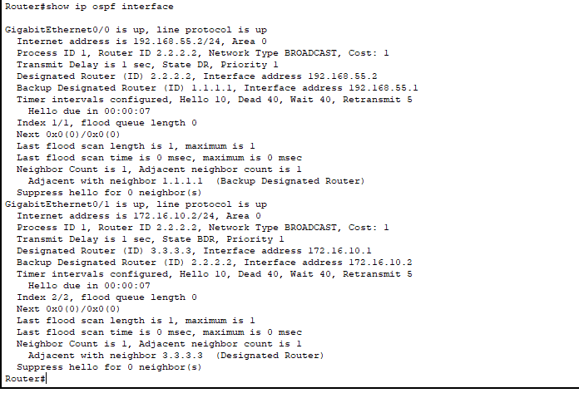

The output shows that Router 1 is actively participating in OSPF Area 0, with both interfaces properly configured and assigned to the OSPF process. Each interface is correctly associated with its respective network, and OSPF adjacencies with neighboring routers are successfully established. The configuration ensures efficient route advertisement and communication between connected devices, reflecting proper OSPF implementation and topology synchronization

|  |  |
| --- | --- |
| **Task 2: Configuration of Multi Area OSPF** |  |
|  |  |

Although basic OSPF configuration can be very simple, OSPF provides many extra features that can get really complex. In this task, we will configure multiarea OSPF network and some other OSPF features.

Consider the following multiarea OSPF network:

[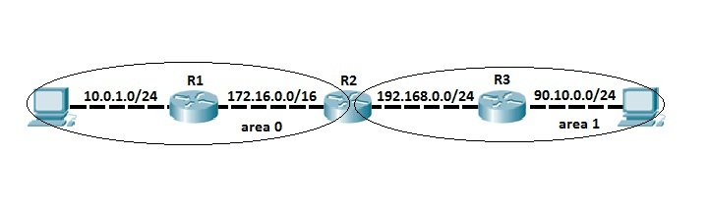](https://603168-1953132-raikfcquaxqncofqfm.stackpathdns.com/wp-content/images/ospf_sample_topology_areas.jpg)

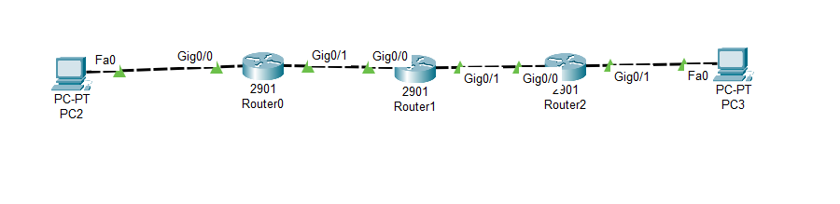

In this task we have two OSPF areas – area 0 and area 1. As you can see from the network topology depicted above, routers R1 and R3 are in the area 0 and area 1, respectively. Router 2 connects to both areas, which makes him an**ABR (Area Border Router)**.

**Attach screenshot of all configuration steps done on R1, R2 and R3 and provide screenshot of your network topology.**

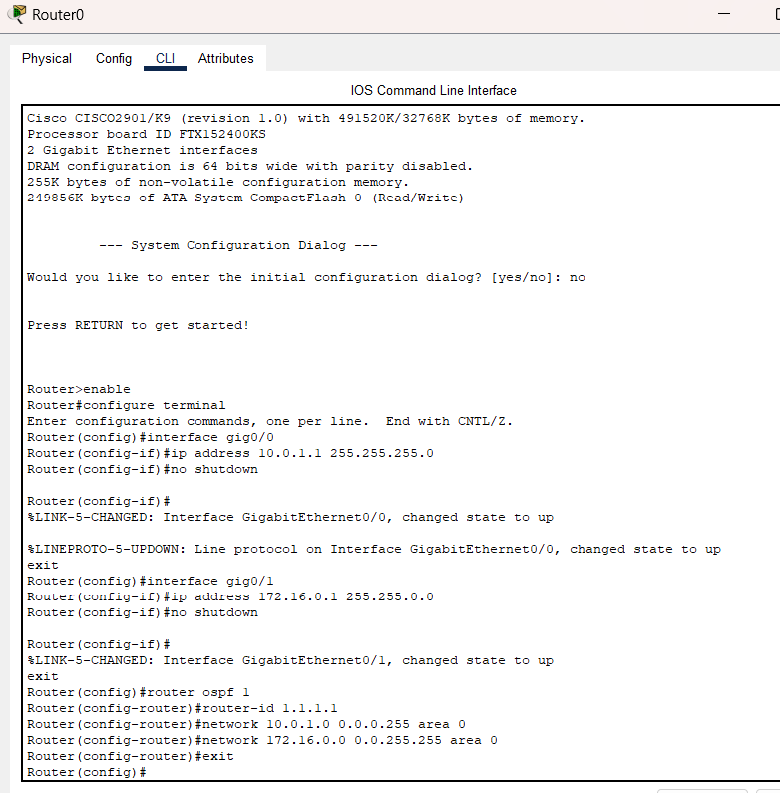

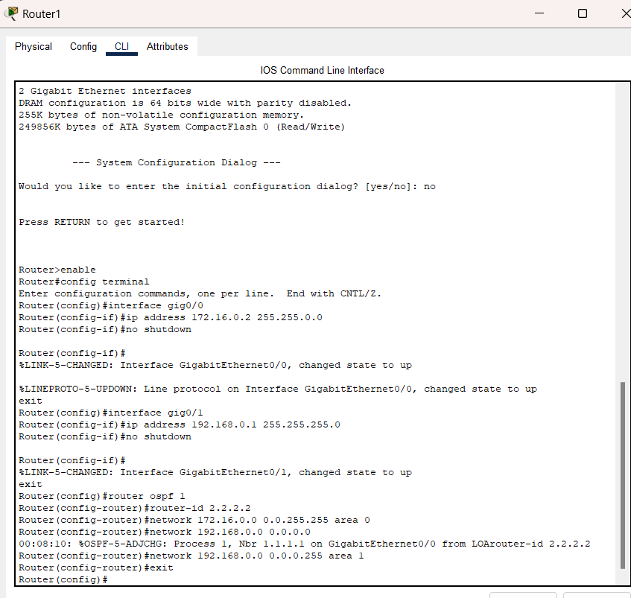

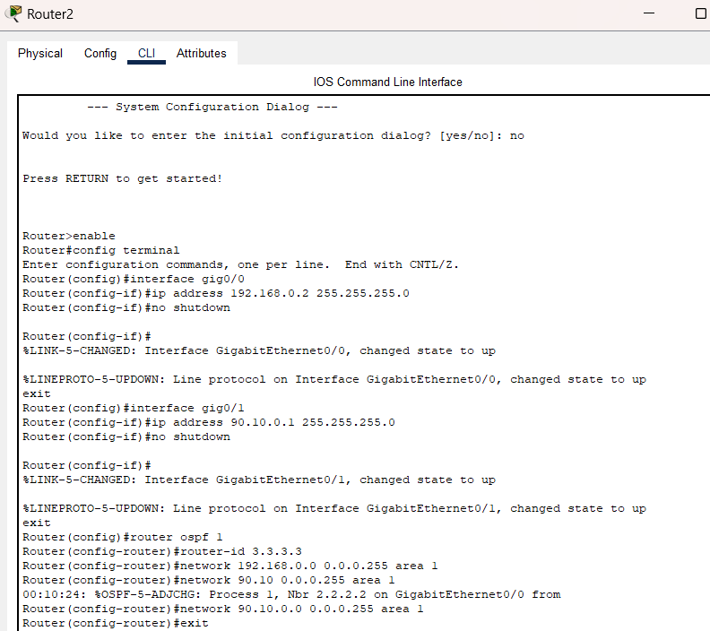

Ping PCs and attach the response below.

|  |
| --- |
|  |

Again, run all below commands and discuss the differences observe in single and multi-area OSPF.

**OSPF verification commands:**

Run show ip protocol on any one Router and discuss the findings.

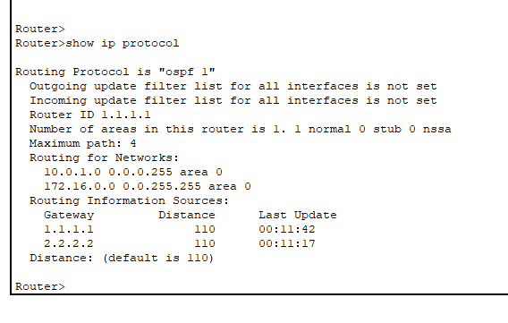

The show ip ospf neighbor output demonstrates that the multi-area OSPF configuration is functioning as expected. Router 1, located in Area 0, lists Router 2 as its neighbor in the FULL/BDR state, indicating successful adjacency within Area 0. Router 2, acting as the Area Border Router (ABR), shows neighbors from both Area 0 and Area 1: Router 1 in FULL/DR state for Area 0 and Router 3 in FULL/BDR state for Area 1. This confirms Router 2’s role in maintaining OSPF adjacencies across both areas. Finally, Router 3, located in Area 1, lists Router 2 as its neighbor in the FULL/DR state, confirming stable OSPF communication between the two areas. These results verify that the multi-area OSPF setup is correctly configured, with proper neighbor relationships and inter-area routing established.

Run show ip route on all routers and discuss the findings.

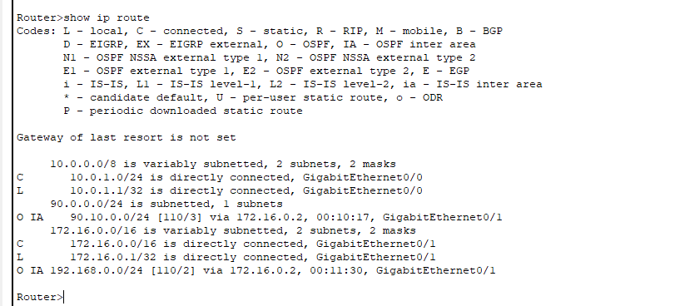

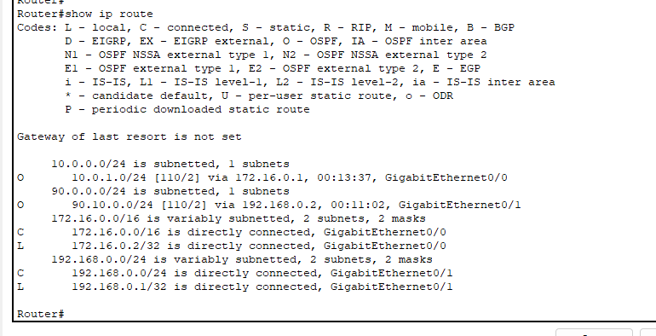

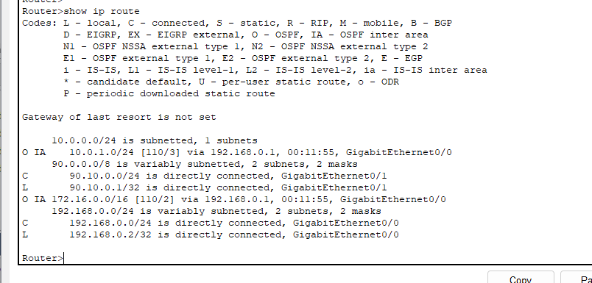

The show ip route output for all routers in Task 2 confirms that OSPF is working correctly in the multi-area setup. Each router's routing table includes the directly connected networks as well as routes learned through OSPF. The inter-area routes are marked with "O IA," indicating they were learned from a different OSPF area. For example, routes on Router 1 and Router 3 correctly include networks from other areas via Router 2, which acts as the Area Border Router (ABR). This shows that OSPF is properly distributing routing information between the areas, ensuring connectivity across the network.

Run below commands, attach its screenshot and **discuss the results.**

* show ip ospf neighbor: Run this command on Router 1, 2 and 3

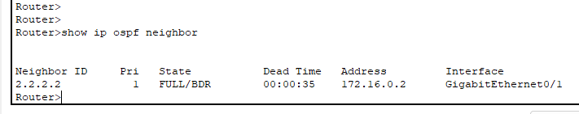

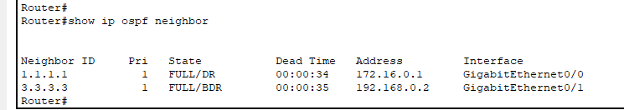

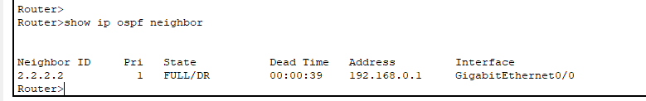

The show ip ospf neighbor output confirms that all routers have established OSPF neighbor relationships successfully. On Router 1, Router 2 is listed as a neighbor in the FULL/BDR state, indicating that Router 2 is the Backup Designated Router (BDR). Router 2 shows two neighbors: Router 1 as FULL/DR (Designated Router) and Router 3 as FULL/BDR. This confirms that Router 2 is acting as the Area Border Router (ABR) between the two OSPF areas. On Router 3, Router 2 is listed as a neighbor in the FULL/DR state, verifying a stable OSPF adjacency. These results demonstrate that OSPF is configured correctly, with proper neighbor relationships established across the network.

* show ip ospf interface: Run this command on any one Router

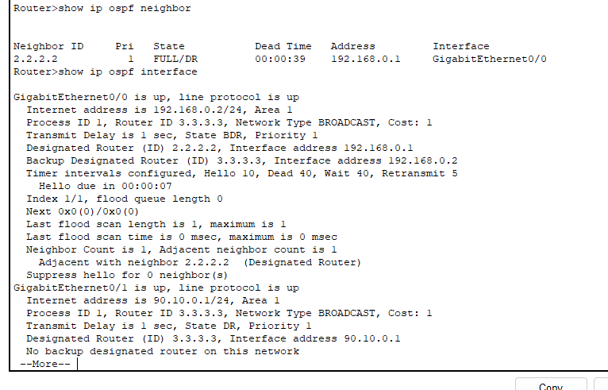

The show ip ospf neighbor output confirms that the router has established a neighbor relationship with Router 2 (Router ID: 2.2.2.2) in the FULL/DR state. This indicates that the router is successfully communicating with Router 2 in Area 1, and the OSPF adjacency is fully established.

The show ip ospf interface output further validates the OSPF configuration across two interfaces. The first interface, with an IP address of 192.168.0.2, is in Area 1 and correctly recognizes Router 2 as the Designated Router (DR) and Router 3 as the Backup Designated Router (BDR). The second interface, with an IP address of 90.10.0.1, is in Area 1 as well and shows no Backup Designated Router, but it does confirm proper OSPF participation. Both interfaces demonstrate that the OSPF process is active and functioning correctly in a multi-area setup, ensuring routing efficiency and stable adjacencies.

**Lab Evaluation Assessment Rubric**

**EE-424 Lab 10**

|  |  |  |  |  |  |
| --- | --- | --- | --- | --- | --- |
| **#** | **Assessment Elements** | **Level 1: Unsatisfactory**  **Points 0-1** | **Level 2: Developing**  **Points 2** | **Level 3: Good**  **Points 3** | **Level 4: Exemplary**  **Points 4** |
| **LR2** | **Program/Code/ Simulation Model/ Network Model** | Program/code/simulation model/network model does not implement the required functionality and has several errors. The student is not able to utilize even the basic tools of the software. | Program/code/simulation model/network model has some errors and does not produce completely accurate results. Student has limited command on the basic tools of the software. | Program/code/simulation model/network model gives correct output but not efficiently implemented or implemented by computationally complex routine. | Program/code/simulation /network model is efficiently implemented and gives correct output. Student has full command on the basic tools of the software. |
| **LR4** | **Data Collection** | Measurements are incomplete, inaccurate and imprecise. Observations are incomplete or not included. Symbols, units and significant figures are not included. | Measurements are somewhat inaccurate and imprecise. Observations are incomplete or vague. Major errors are there in using symbols, units and significant digits. | Measurements are mostly accurate. Observations are generally complete. Minor errors are present in using symbols, units and significant digits. | Measurements are both accurate and precise. Data collection is systematic. Observations are very thorough and include appropriate symbols, units and significant digits and task completed in due time. |
| **LR5** | **Results & Plots** | Figures/ graphs / tables are not developed or are poorly constructed with erroneous results. Titles, captions, units are not mentioned. Data is presented in an obscure manner. | Figures, graphs and tables are drawn but contain errors. Titles, captions, units are not accurate. Data presentation is not too clear. | All figures, graphs, tables are correctly drawn but contain minor errors or some of the details are missing. | Figures / graphs / tables are correctly drawn and appropriate titles/captions and proper units are mentioned. Data presentation is systematic. |
| **AR4** | **\*Report Submission** | Late submission after 1 week and in between 2 weeks. | Late submission after 2 days and within a week. | Late submission after the lab timing and within 2 days of the due date. | Timely submission of the report and in the lab time. |

**\*Report:** Report will not be accepted after due date